31
.

Listen and circle the correct answer :
1 –
A Yes
B No
2-
A Yes
B No
3-
A Yes
B No
4-
A Yes
B No

Listen and number the pictures .

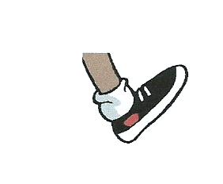 | 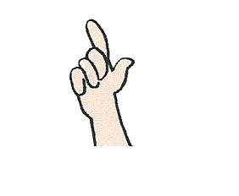 | 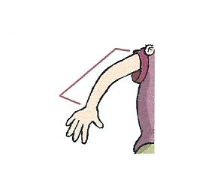
( ) | ( ) | ( )

Listen and tick ( T ) true or ( F ) false :
1 – The girl name's Megan . ( )
2- She goes to school at 9 :00 . ( )
3- Megan watches TV after dinner . ( )
4- She goes to bed at 8:00 at night . ( )
Listen to a story and choose the correct answer :
1 – What's the boy’s name ?
A Salem
B Ali
C Tim
2- How old is he ?
A three
B one
C five

3- Where does he live ?
A Pond Road
B Doha
C Sun Road

4- Tim sees a little …………… .
A cat
B dog
C fish

Reading
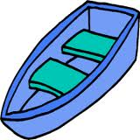
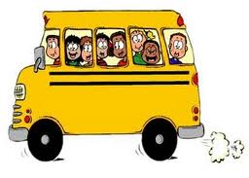
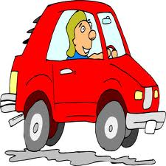

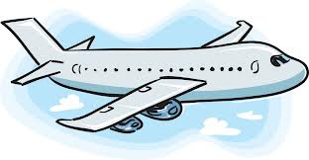
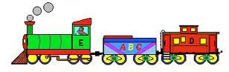
People use many kinds of transportation . Boats float on the water . Some people fish in a boat . Airplanes fly in the sky . Flaying in a plane is fast way to get somewhere . Train runs on a track . A car has four wheels . Most people have cars . It rides on roads . A bus can hold many people . A bus rides on road . Most children ride a bus to school , they have lots of fun in it .

Tick ( T ) for true . ( F ) for fase
- Boats fly in the sky . ( )
- Trains run on a track . ( )
- A bus can hold many people . ( )
- Airplanes float on the water . ( )
Choose the correct answers :
- The best title for the text is :
Swimming Transportation The school
- Most children ride a -------- to school .
bus plane boat
- A car has ------------- wheels .
two four five

Circle the odd one out :
- football tennis skiing black
- dog book pencil ruler
- small fish chicken pasta
- blue green fat yellow
Match words to pictures :
- sugar | 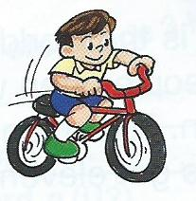  ( )
- snorkeling | 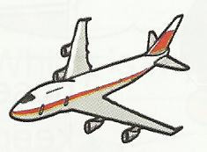  ( )
- jeans | 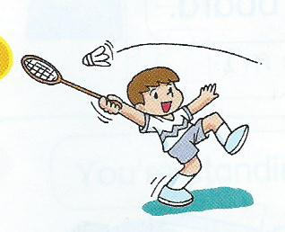  ( )
- cycling | 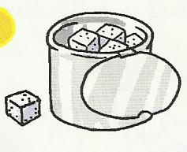  ( )
- plane | 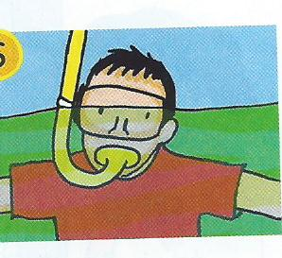  ( )
- badminton | 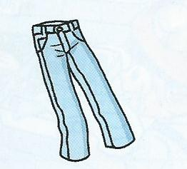  ( )

WRITING

Classify the following words
ruler - flower - raincoat - book - jeans - pot plants

Food

Use Capital letters , ? and .
1 – i'm lost . Could you please help me
--------------------------------------------------

2- my name's sara .
--------------------------------------------------

Label these pictures :

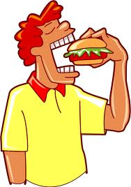  -------------- | 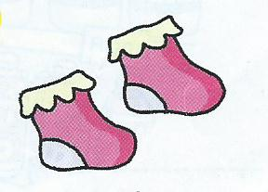  -----------------
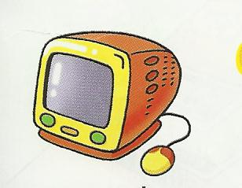  ---------------- | 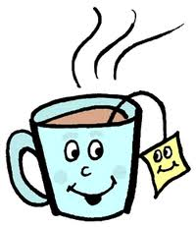  --------------------

Reorder the words to form a sentence .
- playing . like I games
---------------------------------------------------------
- apples ? the much are How
---------------------------------------------------------
- run You mustn't in classroom . the
----------------------------------------------------------

